**Aim:** List of Key Performance Indicators (KPI’s) for teachers and parents, designed to help students m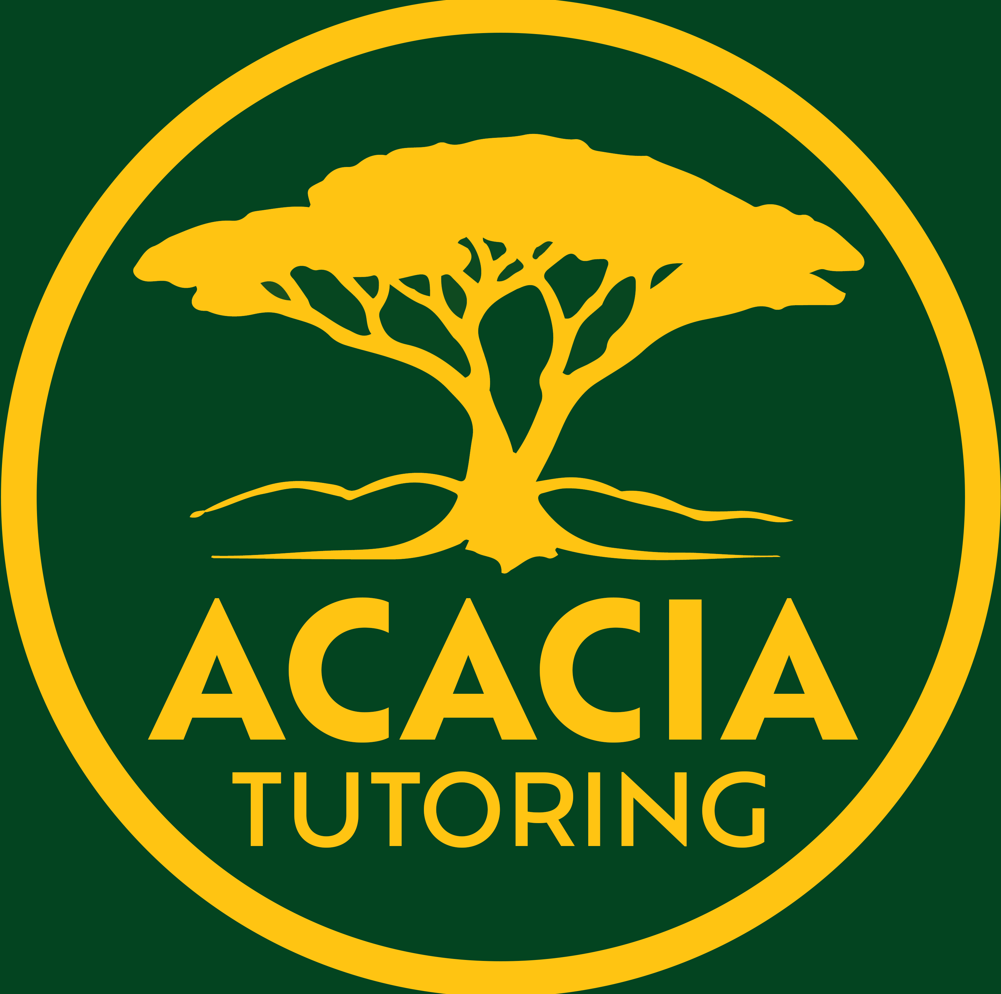aximise their academic achievements and optimise their career trajectory:

Worksheet # 001

# Academic, Life and Career KPI’s for Parents and Teachers

**Printable Series**

Achieved

Progressing

Needs help

|  |  |  |  |
| --- | --- | --- | --- |
| **Academic KPI’s** |  |  |  |
| **1. Consistent Attendance:**  **Indicator:** Attendance rate of at least 95%.  **Rationale:** Regular attendance is fundamental to academic success, ensuring students don't miss out on critical learning opportunities. |  |  |  |
| **2. Academic Progress:**  **Indicator:** Improvement in grades by at least one level per semester in core subjects or maintaining high achievement (A or B grades).  **Rationale:** Demonstrates understanding, retention, and application of learned material. |  |  |  |
| **3. Assessment Performance:**  **Indicator:** Meeting or exceeding school benchmarks in all assessments, including exams, projects, and practical tasks.  **Rationale:** Shows ability to apply knowledge under varied conditions, crucial for tertiary education and professional certifications. |  |  |  |
| **4. Homework Completion:**  **Indicator:** Timely submission of homework with an accuracy or quality score of at least 80%.  **Rationale:** Develops discipline, time management, and reinforces learning. |  |  |  |
| **5. Engagement in Class:**  **Indicator:** Active participation in class discussions, questions asked, and contributions to group work.  **Rationale:** Encourages deeper understanding and critical thinking, key for higher education and workplace collaboration. |  |  |  |
| **6. Research and Study Skills:**  **Indicator:** Use of advanced study techniques (active recall, spaced repetition, etc.) and ability to conduct independent research.  **Rationale:** Prepares students for self-directed learning in university or vocational training. |  |  |  |
| **7. Use of Feedback:**  **Indicator:** Demonstrable improvement in assignments or tests after receiving feedback.  **Rationale:** Shows adaptability and a growth mindset, essential for lifelong learning. |  |  |  |

January 2025

|  |  |  |  |
| --- | --- | --- | --- |
| **Life and Career Preparation KPI’s** |  |  |  |
| **1. Extracurricular Engagement:**  **Indicator:** Participation in at least two extracurricular activities, with a leadership role in one.  **Rationale:** Develops teamwork, leadership, time management, and broadens skill sets beyond academic learning. |  |  |  |
| **2. Career Exploration:**  **Indicator:** Attendance at career expos, participation in career counselling sessions, or completion of career interest assessments.  **Rationale:** Assists in informed decision-making about future career paths. |  |  |  |
| **3. Work Experience or Volunteering:**  **Indicator:** Completion of at least one work experience or volunteering placement during high school.  **Rationale:** Provides practical experience, enhances resume, and connects academic learning to real-world applications. |  |  |  |
| **4. Digital Literacy:**  **Indicator:** Proficiency in using educational technology, understanding digital citizenship, and basic coding or data analysis skills.  **Rationale:** Essential in today's tech-driven world for both academic and career success. |  |  |  |
| **5. Communication Skills:**  **Indicator:** Ability to present ideas clearly in written, oral, and digital formats, including debates or public speaking events.  **Rationale:** Critical for all aspects of professional life, from interviews to project presentations. |  |  |  |
| **6. Resilience and Problem-Solving:**  **Indicator:** Demonstrated ability to navigate academic challenges, recover from setbacks, and solve complex problems.  **Rationale:** Prepares students for the unpredictable nature of career paths and personal life. |  |  |  |
| **7. Networking and Professionalism:**  **Indicator:** Building relationships with teachers, mentors, and community members; understanding professional etiquette.  **Rationale:** Networking is crucial for career advancement, and professionalism is key in all interactions. |  |  |  |
| **8. Goal Setting and Self-Reflection:**  **Indicator:** Setting SMART goals for academic and personal development, with periodic self-assessment.  **Rationale:** Encourages proactive personal growth and career planning. |  |  |  |
| **9. Cultural and Social Awareness:**  **Indicator:** Participation in cultural exchange programs or community service projects that address social issues.  **Rationale:** Develops empathy, cultural competence, and a global perspective, vital in diverse workplaces. |  |  |  |

Needs help

Progressing

Achieved

Notes section over page…



|  |
| --- |
| Notes: |
|  |
|  |
|  |
|  |
|  |
|  |
|  |
|  |
|  |
|  |
|  |
|  |
|  |
|  |
|  |

IMPORTANT: At Acacia Tutoring we believe all educational resources should be free, as education, is a fundamental human right and a cornerstone of an equitable society. By removing financial barriers, we ensure that all students, regardless of their socioeconomic background, have equal access to high-quality learning materials. This inclusivity promotes fairness, helps bridge achievement gaps, and fosters a society where every individual can reach their full potential.

Furthermore, free resources empower teachers and parents, providing them with tools to support diverse learners and improve outcomes across communities. Education benefits everyone, and making resources universally accessible ensures we build a more informed, skilled, and prosperous future for all.

All documents are formatted as a **.pdf** file, and are completely **FREE** to use, print and distribute - as long as they are not sold or reproduced to make a profit.

N.B. Although we try our best to produce high-quality, accurate and precise materials, we at Acacia Tutoring are still human, these documents may contain errors or omissions, if you find any and wish to help, please contact Jason at [info@acaciatutoring.com.au](mailto:info@acaciatutoring.com.au) .