**Aim:** List of Key Performance Indicators (KPI’s), designed to help students maximise their a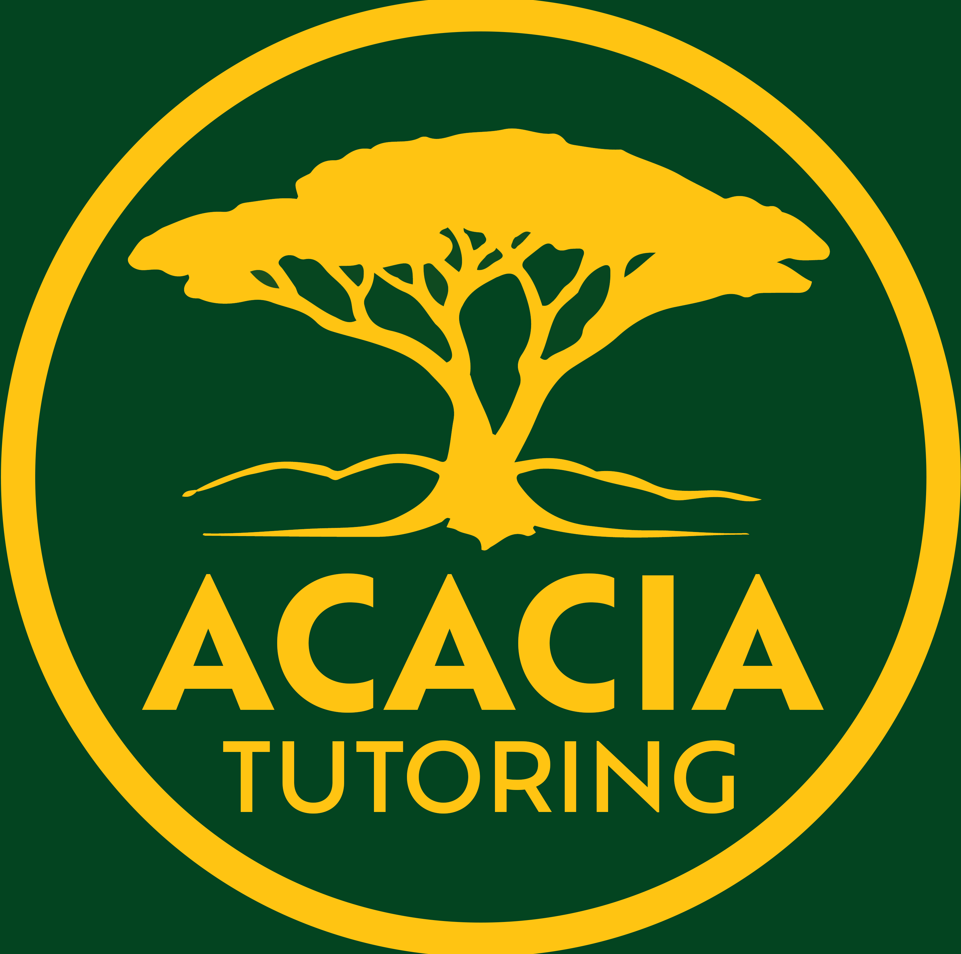cademic achievements and optimise their career trajectory:

Worksheet # 002

# Academic, Life and Career KPI’s Student Survey

**Printable Series**

January 2025

Needs help

Progressing

Achieved

|  |  |  |  |
| --- | --- | --- | --- |
| **Academic KPI’s** |  |  |  |
| **1. Consistent Attendance**  **Question:** What is your current attendance rate?  **Check:** Is it at or above 95%?  *Answer:* |  |  |  |
| **2. Academic Progress**  **Question:** How have your grades changed in core subjects this semester?  **Check:** Have you improved by at least one level or maintained high achievement (A or B grades)?  *Answer:* |  |  |  |
| **3. Assessment Performance**  **Question:** How did you perform in your latest assessments?  **Check:** Did you meet or exceed the school benchmarks (C grade)?  *Answer:* |  |  |  |
| **4. Homework Completion**  **Question:** What percentage of homework did you complete on time this term?  **Check:** Was the quality or accuracy of your homework at least 80%?  *Answer:* |  |  |  |
| **5. Engagement in Class**  **Question:** How often do you participate in class discussions or group activities?  **Check:** Are you actively engaging by asking questions or contributing ideas?  *Answer:* |  |  |  |
| **6. Research and Study Skills**  **Question:** Which advanced study techniques are you using (e.g., active recall, spaced repetition)?  **Check:** Can you demonstrate independent research in your projects?  *Answer:* |  |  |  |
| **7. Use of Feedback**  **Question:** How have you improved your work after receiving feedback?  **Check:** Is there noticeable improvement in subsequent assignments or tests?  *Answer:* |  |  |  |

|  |  |  |  |
| --- | --- | --- | --- |
| **Life and Career Preparation KPI’s** |  |  |  |
| **1. Extracurricular Engagement**  **Question:** What extracurricular activities are you involved in?  **Check:** Are you participating in at least two, with a leadership role in one?  *Answer:* |  |  |  |
| **2. Career Exploration**  **Question:** Have you attended career expos or participated in career counselling?  **Check:** Have you completed any career interest assessments?  *Answer:* |  |  |  |
| **3. Work Experience or Volunteering**  **Question:** Describe any work experience or volunteering you've done.  **Check:** Have you completed at least one placement during high school?  *Answer:* |  |  |  |
| **4. Digital Literacy**  **Question:** What digital tools or technologies have you mastered?  **Check:** Do you understand digital citizenship and have basic coding or data analysis skills?  *Answer:* |  |  |  |
| **5. Communication Skills**  **Question:** How do you practise presenting ideas (e.g., debates, speeches)?  **Check:** Can you demonstrate clear communication in various formats?  *Answer:* |  |  |  |
| **6. Resilience and Problem-Solving**  **Question:** Describe a time you overcame an academic or personal challenge.  **Check:** Have you shown ability to solve complex problems or recover from setbacks?  *Answer:* |  |  |  |
| **7. Networking and Professionalism**  **Question:** Who are your mentors or professional contacts?  **Check:** Are you building relationships and understanding professional etiquette?  *Answer:* |  |  |  |
| **8. Goal Setting and Self-Reflection**  **Question:** What SMART goals have you set for this year?  **Check:** Do you regularly assess your progress towards these goals?  *Answer:* |  |  |  |
| **9. Cultural and Social Awareness**  **Question:** What cultural or community service projects have you been part of?  **Check:** Are you developing cultural competence and social awareness?  *Answer:* |  |  |  |

Progressing

Achieved

Needs help

Continued over page…

|  |  |  |  |
| --- | --- | --- | --- |
| **10. Physical and Mental Health**  **Question:** How do you manage your physical and mental wellbeing?  **Check:** Are you regularly participating in sports or wellness programs?  *Answer:*  **Further:** The following indicators are paramount to good mental health.   * **Physical health** Balanced diet, enough sleep (around 8 hours), participation in sporting activities. * **Social connections** Strong and maintained relationships with family, friends and others. Participation in social activities. * **Emotional wellness** Practice of gratitude, mindfulness, time for private reflection. * **Stress management** Ability to manage stressful situations and periods. * **Self-care** Ability to take care of basic needs and practice of establishing boundaries amongst relationships. * **Resilience** Ability to remain resilient during difficult experiences and periods. * **Meaningful activities** Participation in positive activities that encourage growth.   *Use the checklist to the right to check off each section.* |  |  |  |
| **11. Measurement and Tracking**  **Regular Assessments:** Use academic tests, teacher observations, and self-assessment tools.  **Portfolio Development:** Maintain a portfolio showcasing achievements in both academic and extracurricular activities.  **Feedback Loops:** Ensure there's ongoing feedback from teachers, peers, and self, with opportunities for reflection and adjustment.  **Career Portfolios:** For older students, include resume development, LinkedIn profiles, or similar professional platforms.  *Use checklist to the right to check off each section.* |  |  |  |

|  |
| --- |
| Notes: |
|  |
|  |
|  |
|  |
|  |
|  |
|  |
|  |
|  |

**KPI Checklist - Student Example**

**Academic KPI’s Checklist**

**1. Consistent Attendance**

**Question:** What is your current attendance rate?

**Check:** Is it at or above 95%?

**Example:** My attendance this semester is 97%, which is above 95%.

**2. Academic Progress**

**Question:** How have your grades changed in core subjects this semester?

**Check:** Have you improved by at least one level or maintained high achievement (A or B grades)?

**Example:** I improved from a C to an C+ in Mathematics.

**3. Assessment Performance**

**Question:** How did you perform in your latest assessments?

**Check:** Did you meet or exceed the school benchmarks scoring a grade C or higher?

**Example:** I scored an 85% which was a B grade.

**4. Homework Completion**

**Question:** What percentage of homework did you complete on time this term?

**Check:** Was the quality or accuracy of your homework at least 80%?

**Example:** I completed 90% of my homework on time, with an average score of 85%.

**5. Engagement in Class**

**Question:** How often do you participate in class discussions or group activities?

**Check:** Are you actively engaging by asking questions or contributing ideas?

**Example:** Iactively contribute to class discussions at least three times per lesson.

**6. Research and Study Skills**

**Question:** Which advanced study techniques are you using (e.g., active recall, spaced repetition)?

**Check:** Can you demonstrate independent research in your projects?

**Example:** I use spaced repetition for vocabulary in French and I have produced a detailed research project on renewable energy in Science.

**7. Use of Feedback**

**Question:** How have you improved your work after receiving feedback?

**Check:** Is there noticeable improvement in subsequent assignments or tests?

**Example:** After receiving feedback on my first essay, I revised my writing style, leading to an improvement from a C to an B in the following assignment.

**Life and Career Preparation KPI’s Checklist**

**1. Extracurricular Engagement**

**Question:** What extracurricular activities are you involved in?

**Check:** Are you participating in at least two, with a leadership role in one?

**Example:** I play in the school band and I captain the chess club.

**2. Career Exploration**

**Question:** Have you attended career expos or participated in career counselling?

**Check:** Have you completed any career interest assessments?

**Example:** I attended a tech expo and took a career aptitude test that confirmed my interest in engineering.

**3. Work Experience or Volunteering**

**Question:** Describe any work experience or volunteering you've done.

**Check:** Have you completed at least one placement during high school?

**Example:** I volunteered at a local animal shelter for three months, learning about animal care and community service.

**4. Digital Literacy**

**Question:** What digital tools or technologies have you mastered?

**Check:** Do you understand digital citizenship and have basic coding or data analysis skills?

**Example:** I have mastered Adobe Photoshop for my art projects and I understand the principles of digital citizenship, including privacy and online safety.

**5. Communication Skills**

**Question:** How do you practice presenting ideas (e.g., debates, speeches)?

**Check:** Can you demonstrate clear communication in various formats?

**Example:** Iparticipated in the school debate team, helping me improve my public speaking and argumentation skills.

**6. Resilience and Problem-Solving**

**Question:** Describe a time you overcame an academic or personal challenge.

**Check:** Have you shown ability to solve complex problems or recover from setbacks?

**Example:** Following a poor performance in my mid-term exams, I devised a new study plan and improved my grades by the end of the semester.

**7. Networking and Professionalism**

**Question:** Who are your mentors or professional contacts?

**Check:** Are you building relationships and understanding professional etiquette?

**Example:** I have built a good rapport with my science teacher, who mentors me in science club activities, teaching me about professional conduct.

**8. Goal Setting and Self-Reflection**

**Question:** What SMART goals have you set for this year?

**Check**: Do you regularly assess your progress towards these goals?

**Example:** I set a goal to read 20 books this year; and I review my progress monthly.

**9. Cultural and Social Awareness**

**Question:** What cultural or community service projects have you been part of?

**Check:** Are you developing cultural competence and social awareness?

**Example:** Iparticipated in a cultural exchange program with a school in Japan, enhancing my cultural understanding and language skills.

**10. Physical and Mental Health**

**Question:** How do you manage your physical and mental wellbeing?

**Check:** Are you regularly participating in sports or wellness programs?

**Example:** I manage my wellbeing through regular swimming sessions and mindfulness meditation to cope with exam stress.

**KPI Checklist - Actionable Steps**

Here are actionable steps to help students to meet the Key Performance Indicators (KPI’s) for academic and career optimisation:

**Academic KPI’s:**

**1. Consistent Attendance:**

Actionable Steps:

Set multiple alarms to ensure you wake up on time for school.

Plan your day to account for travel time, ensuring you're not rushed.

If sick, arrange for notes or online class access to keep up with lessons.

**2. Academic Progress:**

Actionable Steps:

Create a study schedule that includes review sessions for each subject weekly.

Use tutoring or peer study groups for subjects you find challenging.

Set specific, measurable academic goals at the start of each term.

**3. Assessment Performance:**

Actionable Steps:

Practice with past exam papers under timed conditions.

Develop a checklist for each type of assessment (essay, project, exam) to ensure all criteria are met.

Regularly review and adjust study strategies based on assessment outcomes.

**4. Homework Completion:**

Actionable Steps:

Use a homework planner or app to track assignments and deadlines.

Allocate specific times for homework in your daily schedule.

Break large assignments into smaller, manageable tasks with mini-deadlines.

**5. Engagement in Class:**

Actionable Steps:

Prepare questions or points for discussion before class.

Actively listen and take notes, not just to remember but to engage with the content.

Volunteer for group activities or presentations to enhance participation.

**6. Research and Study Skills:**

Actionable Steps:

Attend workshops or online courses on research methods or study techniques.

Practice summarising readings or lectures in your own words.

Use tools like flashcards or mind maps for complex subjects.

**7. Use of Feedback:**

Actionable Steps:

Keep a feedback journal where you note down all comments and how you'll address them.

After receiving feedback, immediately update your study plan or approach.

Discuss feedback with teachers to clarify and ensure understanding.

**Life and Career Preparation KPI’s:**

**1. Extracurricular Engagement:**

Actionable Steps:

Join clubs or sports teams at school, committing to regular attendance.

Take on small leadership roles like managing a team project or leading a club meeting.

Reflect on your involvement in extracurriculars in personal statements or portfolios.

**2. Career Exploration:**

Actionable Steps:

Schedule career counselling sessions at school or through community services.

Attend industry talks, webinars, or open days at universities or workplaces.

Complete online career assessments to identify your interests and strengths.

**3. Work Experience or Volunteering:**

Actionable Steps:

Apply for work experience placements early in the school year.

Volunteer for local community projects or charities, even if for a few hours a week.

Document your experiences with reflections or a work diary.

**4. Digital Literacy:**

Actionable Steps:

Enrol in basic coding or data literacy courses available online or through school.

Practice using software tools relevant to your future career (e.g., Excel, coding platforms).

Learn about digital security and privacy by attending or watching relevant workshops.

**5. Communication Skills:**

Actionable Steps:

Join debate or public speaking clubs to practice articulation and persuasion.

Write letters to the editor or blog posts on topics of interest to refine writing skills.

Engage in mock interviews with teachers or peers to improve professional communication.

**6. Resilience and Problem-Solving:**

Actionable Steps:

Reflect on setbacks in a journal, focusing on what was learned and how to move forward.

Engage in problem-based learning activities or puzzles to enhance critical thinking.

Develop a plan for stress management or coping with failure, like mindfulness exercises.

**7. Networking and Professionalism:**

Actionable Steps:

Attend networking events or join LinkedIn to connect with professionals in your field of interest.

Practice professional email etiquette by writing to teachers or professionals for guidance.

Dress appropriately for any career or networking event to show professionalism.

**8. Goal Setting and Self-Reflection:**

Actionable Steps:

Use SMART goal templates to set clear, achievable objectives for each term.

Schedule regular self-assessment sessions, perhaps monthly, to track progress.

Write reflective essays or journal entries on personal development and career goals.

**9. Cultural and Social Awareness:**

Actionable Steps:

Participate in cultural exchange programs or cultural events at school.

Volunteer for projects that aim at social change or community improvement.

Read widely on various cultures or social issues to broaden your perspective.

**10. Physical and Mental Health:**

Actionable Steps:

Incorporate a daily physical activity, even if it's just a walk or stretching session.

Learn and practice relaxation techniques like meditation or yoga.

Seek out school or community mental health resources when needed.

By implementing these actionable steps, students can tangibly work towards meeting their KPI’s, fostering both academic excellence and personal development for a successful future.

IMPORTANT: At Acacia Tutoring we believe all educational resources should be free, as education, is a fundamental human right and a cornerstone of an equitable society. By removing financial barriers, we ensure that all students, regardless of their socioeconomic background, have equal access to high-quality learning materials. This inclusivity promotes fairness, helps bridge achievement gaps, and fosters a society where every individual can reach their full potential.

Furthermore, free resources empower teachers and parents, providing them with tools to support diverse learners and improve outcomes across communities. Education benefits everyone, and making resources universally accessible ensures we build a more informed, skilled, and prosperous future for all.

All documents are formatted as a **.pdf** file, and are completely **FREE** to use, print and distribute - as long as they are not sold or reproduced to make a profit.

N.B. Although we try our best to produce high-quality, accurate and precise materials, we at Acacia Tutoring are still human, these documents may contain errors or omissions, if you find any and wish to help, please contact Jason at [info@acaciatutoring.com.au](mailto:info@acaciatutoring.com.au) .